SIMATS ENGINEERING ASSESSMENT TOOL 3: Application Based Questions

COURSE NAME: Cloud Computing and Big Data Analytics
COURSE CODE: CSA1508

COURSE OUTCOME COVERED
CO2: Analyze virtualization architectures to identify performance and security issues in cloud computing environments. (BL3)

Dave's Taxonomy: Manipulation (Level 2) Total Marks: 25
Question Count: 5

Code of Conduct
I L.SIVA TEJA(192311073) (Name / Reg No) certify that this submission is my original work and that I have adhered to the guidelines specified for this assessment.
I understand that any violation of academic integrity rules will result in disciplinary action. Signature of the student: L.SIVA TEJA

Assessment Tasks

Application Based Questions

- A company experiences unpredictable traffic spikes during seasonal sales. Explain how cloud auto-scaling and load balancing can handle this demand efficiently. How does this approach reduce downtime and improve user experience? What role do monitoring tools play in this setup? Relate your answer to a real-world e-commerce scenario.
Answer:

Auto-Scaling & Load Balancing for Seasonal Traffic Spikes

Relevance to the Scenario
A company facing unpredictable seasonal spikes (e.g., Black Friday or a festival sale) needs infrastructure that expands and contracts automatically with demand, rather than being sized for either the average day (causing crashes at peak) or the peak day (wasting money the rest of the year). Cloud auto-scaling and load balancing together solve exactly this mismatch between fixed capacity and variable demand.

How Auto-Scaling and Load Balancing Work Together
- Auto-scaling: A scaling policy watches metrics such as CPU utilization, request latency, or queue length. When traffic climbs beyond a threshold, new server instances are automatically launched within minutes; when traffic falls, the extra instances are terminated. This means capacity tracks demand in near real time instead of being fixed in advance.
- Load balancing: A load balancer sits in front of the fleet of servers and distributes each incoming request to a healthy instance, using algorithms such as round-robin or least-connections. It also continuously health-checks servers and stops sending traffic to any that fail, so a single crashed instance never becomes a bottleneck or a visible outage.
- Together: The load balancer makes the growing/shrinking pool of servers look like one seamless service to the customer, while auto-scaling makes sure that pool is always the right size.
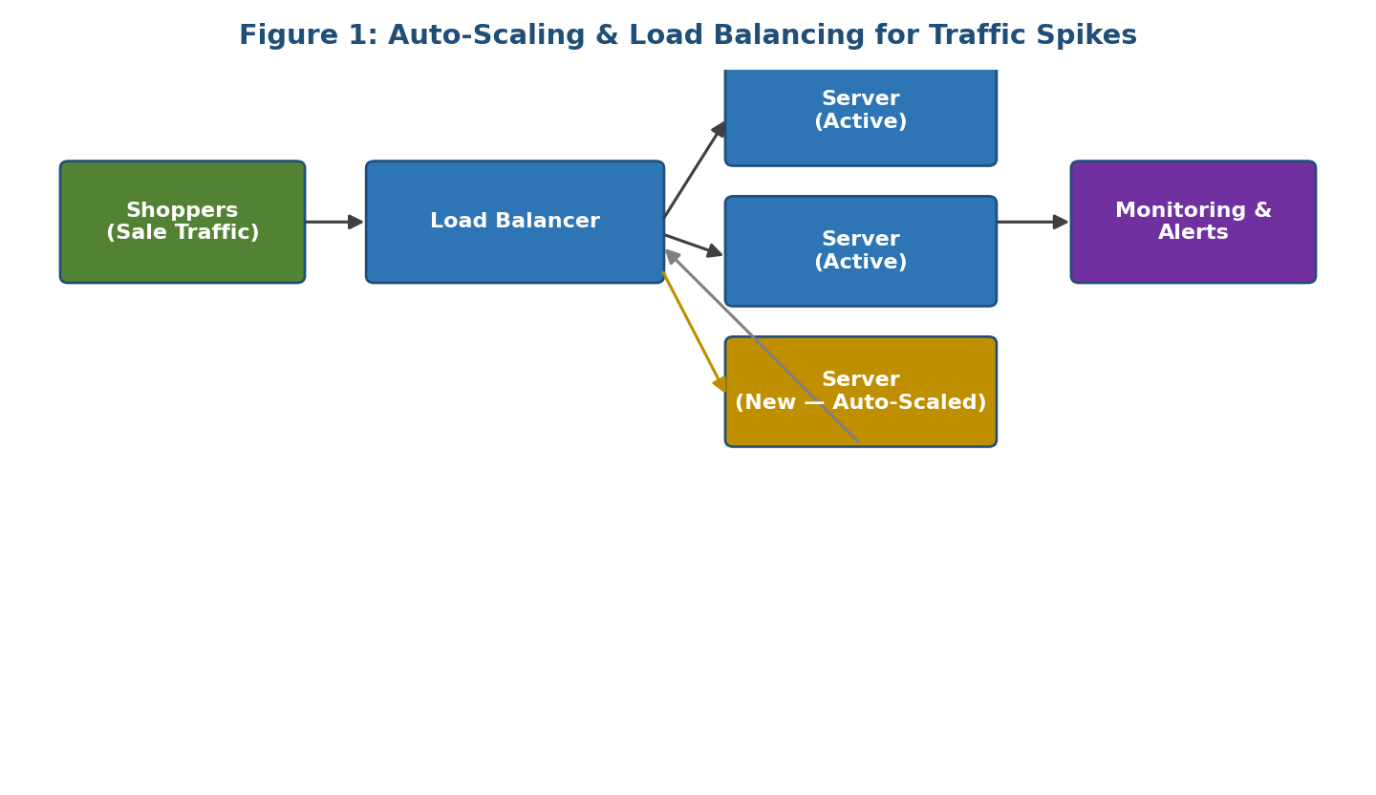
Figure 1: Auto-scaled server pool behind a load balancer, monitored continuously.

Reducing Downtime and Improving User Experience
Because new capacity comes online automatically before servers are fully saturated (scaling on a leading indicator like CPU or queue depth, not on outright failure), the system avoids the slow page loads, checkout failures, and timeouts that would otherwise occur during a spike. The load balancer's health checks also mean a failing instance is silently routed around, so users rarely notice individual server failures. The net effect is that response times stay consistent whether there are 1,000 or 1,000,000 concurrent shoppers.

Role of Monitoring Tools
Monitoring tools (e.g., CloudWatch, Azure Monitor, or a Prometheus/Grafana stack) are what make auto-scaling and load balancing intelligent rather than reactive-only. They collect real-time metrics that scaling policies act on, provide dashboards for engineers to watch traffic trends live during a sale, and trigger alerts if error rates or latency creep up despite scaling — flagging problems such as a downstream database becoming the new bottleneck once the web tier has scaled out. Monitoring also produces the historical data needed to fine-tune scaling thresholds ahead of the next sale.

Real-World E-Commerce Example
A large e-commerce platform running an annual flash sale typically sees traffic jump five to ten times its normal level within minutes of the sale opening. By combining auto-scaling groups for the web and application tiers with a load balancer in front, and a caching layer to protect the database from repeated product-page reads, such platforms keep checkout flows responsive and avoid the 'sold out due to site crash' scenario that damages both revenue and customer trust — scaling capacity up during the surge and back down once the sale ends to control cost.

- An organization wants to store large volumes of backup data securely in the cloud. Discuss how cloud storage solutions ensure durability and data redundancy.
How can encryption and access control protect sensitive backup data?
Explain the cost advantages compared to traditional storage systems. Provide an example of a disaster recovery use case.
Answer:

Secure, Durable Cloud Backup Storage

Relevance to the Scenario
An organization storing large volumes of backup data in the cloud needs three things simultaneously: the data must survive hardware failures (durability), remain confidential and tamper-resistant (security), and cost less than running equivalent on-premises storage infrastructure. Cloud storage services are purpose-built to satisfy all three.

Durability and Data Redundancy
Cloud object storage services achieve very high durability (commonly advertised as 99.999999999% — '11 nines') by automatically storing multiple copies of every object across physically separate storage devices, and often across separate availability zones within a region. If one disk, server, or even an entire data center fails, the data remains intact and accessible from the surviving copies, with the storage system automatically re-replicating to restore full redundancy. Optional cross-region replication extends this protection to an entire regional outage.
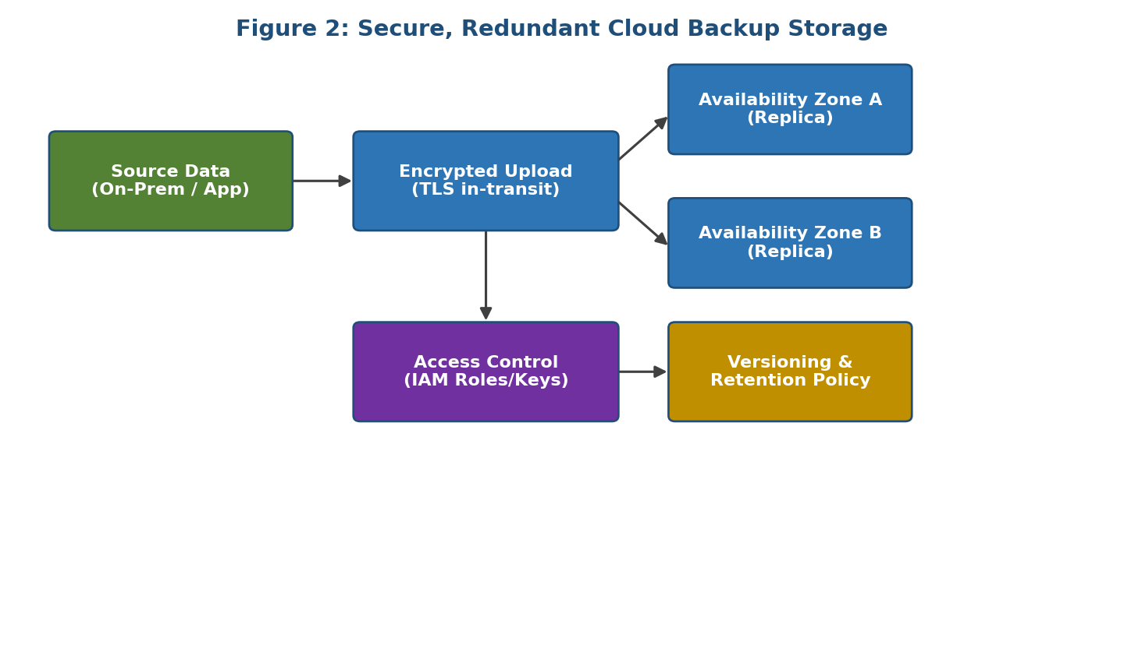
Figure 2: Encrypted backup upload, multi-zone replication, and access-controlled retention.

Encryption and Access Control
- Encryption at rest: Backup data is encrypted on disk using strong algorithms (e.g., AES-256), with encryption keys managed either by the provider or by the customer via a dedicated key-management service, so stolen physical media or unauthorized backend access cannot expose readable data.
- Encryption in transit: Data moving to and from the storage service is protected with TLS, preventing interception during upload or restore.
- Access control: Identity and Access Management (IAM) policies restrict exactly who and what (users, applications, service accounts) can read, write, or delete backup data, following the principle of least privilege. Multi-factor authentication and bucket/container-level policies add further layers, and features like object versioning or write-once-read-many (WORM) locks can prevent even an authorized account from permanently deleting backups prematurely.

Cost Advantages Compared to Traditional Storage
- No upfront capital expenditure on physical storage hardware, RAID arrays, or a secondary backup data center.
- Pay-as-you-go pricing means the organization pays only for the storage actually consumed, scaling automatically as backup volume grows.
- Storage tiering (hot, cool, archive) lets older, rarely accessed backups move automatically to much cheaper storage classes.
- No ongoing cost of power, cooling, physical security, or hardware refresh cycles that traditional on-premises storage requires.

Disaster Recovery Use Case Example
Consider a company whose primary data center suffers a fire or major hardware failure. Because its critical databases were being backed up nightly to cloud object storage with cross-region replication enabled, the IT team can provision new compute resources in the cloud (or a recovery site) and restore the most recent backup within the organization's defined Recovery Time Objective, rather than losing the business entirely while waiting to rebuild physical infrastructure.

- A mobile app company plans to deploy its application globally. Explain how content delivery networks (CDNs) improve performance and reduce latency. How do edge servers enhance user experience across regions? Discuss how cloud providers support global availability. Relate this to a real-time streaming or gaming application.
Answer:

CDNs and Edge Servers for Global App Performance

Relevance to the Scenario
A mobile app company deploying globally faces a fundamental physics problem: the further a user is from the server, the longer each request takes due to network round-trip time. A user in Tokyo hitting a server in Virginia will always experience more latency than a user in Washington, D.C. — no amount of server-side optimization removes that distance penalty. Content Delivery Networks (CDNs) and edge servers exist specifically to solve this.

How CDNs Improve Performance and Reduce Latency
A CDN is a globally distributed network of servers (points of presence) that cache copies of static and semi-static content — images, videos, app assets, API responses that don't change per-request — close to end users. When a user requests content, it is served from the nearest CDN edge node rather than traveling all the way back to the origin server, cutting round-trip latency dramatically and reducing load on the origin. CDNs also often provide built-in DDoS protection and TLS termination at the edge, improving both performance and security simultaneously.
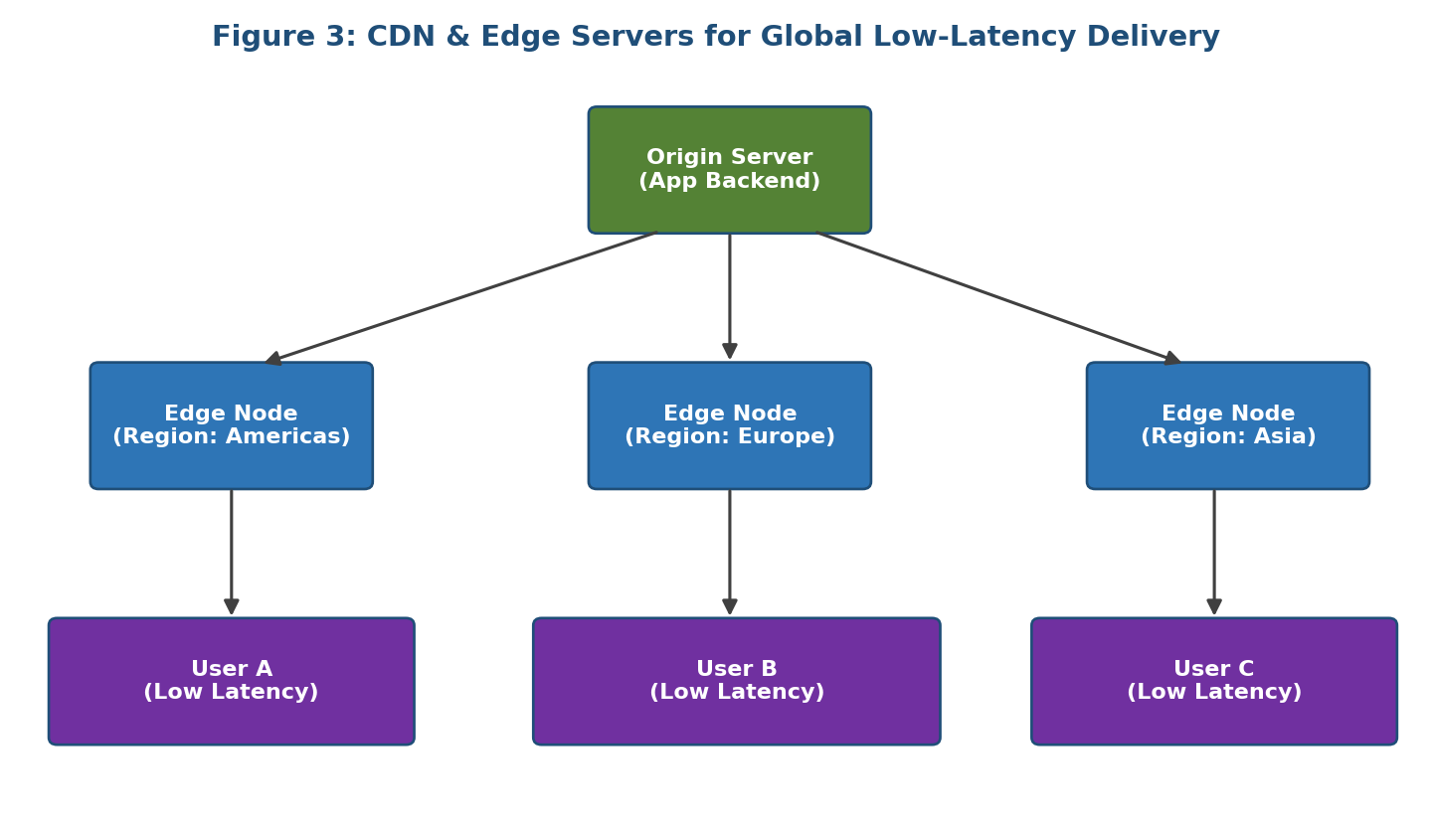
Figure 3: Origin server replicated to regional edge nodes, each serving nearby users directly.

How Edge Servers Enhance User Experience
Edge servers go a step further than simple content caching by running actual compute close to the user — for example, authentication checks, personalization logic, or real-time data aggregation — rather than sending every request back to a central origin. For a mobile app, this means faster app launches, quicker in-app content updates, and lower perceived lag when interacting with the app, because many operations are resolved within a few milliseconds' network distance instead of crossing an ocean.

Global Availability Support from Cloud Providers
- Major cloud providers operate CDN and edge networks spanning dozens to hundreds of points of presence worldwide.
- Global load balancing/DNS routing automatically directs each user to their nearest healthy edge location.
- Multi-region origin deployments let the backend itself run closer to users, not just the cached content.
- Provider SLAs guarantee defined uptime and latency targets across regions, which the company can build its own service-level commitments on top of.

Real-Time Streaming / Gaming Example
A live-streaming or mobile gaming platform is extremely latency-sensitive — even 100–200 milliseconds of added lag is noticeable to users and can break a competitive multiplayer match or cause visible buffering in a live stream. Such platforms rely heavily on CDN edge caching for video segments and static game assets, combined with edge compute nodes handling real-time features like matchmaking or chat, so that players and viewers across different continents all get a responsive experience close to what someone near the origin server would get.

- A financial institution requires strict compliance and data security in cloud usage. Explain how cloud providers support regulatory compliance and auditing. What role do logging, monitoring, and encryption play in security? How can the company ensure data sovereignty requirements are met? Give an example involving sensitive financial transactions.
Answer:

Compliance and Security for a Financial Institution

Relevance to the Scenario
A financial institution operates under strict regulatory regimes (such as PCI-DSS for card data, and regional data-protection or banking regulations) that mandate specific controls over how data is secured, who can access it, where it may be stored, and how activity is recorded. Cloud usage must be architected from the start to satisfy these obligations, not retrofitted afterward.

How Cloud Providers Support Regulatory Compliance and Auditing
Major cloud providers maintain independently audited compliance certifications (e.g., PCI-DSS, SOC 2, ISO 27001) for their infrastructure and publish detailed compliance documentation, which the financial institution can rely on as part of its own compliance evidence under a shared-responsibility model — the provider secures the underlying infrastructure, while the institution is responsible for correctly configuring and using the services on top of it. Providers also offer built-in compliance and configuration-auditing tools that continuously check resource configurations against regulatory benchmarks and flag drift.
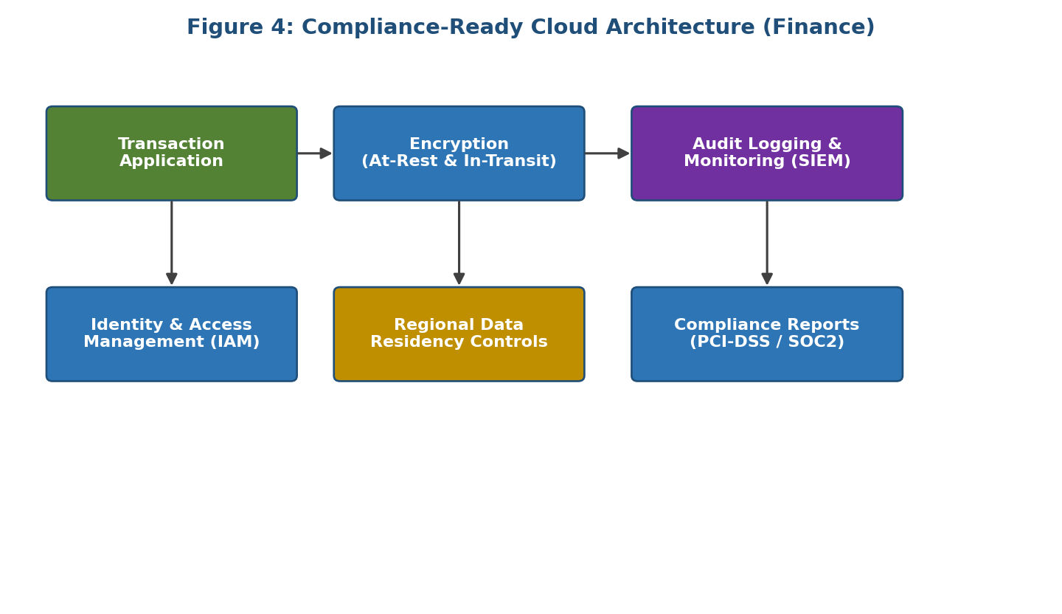
Figure 4: Encryption, IAM, data-residency controls, and audit logging supporting regulatory compliance.

Role of Logging, Monitoring, and Encryption
- Logging: Every access to sensitive systems and data (who accessed what, when, and from where) is recorded in immutable audit logs, which regulators and internal auditors can review to reconstruct exactly what happened during an incident or routine audit.
- Monitoring: Security monitoring tools (often a SIEM — security information and event management system) continuously analyze logs and network activity for suspicious patterns, such as unusual login locations or abnormal transaction volumes, enabling near real-time detection of fraud or intrusion attempts.
- Encryption: Encrypting data at rest and in transit ensures that even if data is intercepted or storage media is compromised, transaction details and customer financial information remain unreadable without the proper keys, directly satisfying most regulatory encryption mandates.

Meeting Data Sovereignty Requirements
Data sovereignty rules typically require that certain categories of financial data physically remain within a specific country or region's borders. The institution can meet this by selecting cloud regions located within the required jurisdiction, using data-residency controls to pin storage and processing to those regions, and using the API-gateway or gateway-service pattern so that any cross-border integrations only exchange non-sensitive, permitted data — never the raw regulated records.

Example Involving Sensitive Financial Transactions
Consider a bank processing card payments: each transaction is encrypted end-to-end from the point of sale to the payment processor, tokenized so the actual card number is never stored in the application database, logged in an immutable audit trail for reconciliation and fraud investigation, and processed entirely within cloud regions located in the country where the banking regulator requires the data to remain — allowing the bank to pass PCI-DSS audits while still benefiting from cloud scalability.

- A development team wants to adopt containerization for application deployment. Explain how containers differ from virtual machines in terms of performance and resource usage. How does orchestration (like Kubernetes) simplify deployment and scaling? Discuss portability benefits across different cloud environments. Provide an example of a microservices-based application.
Answer:

Containerization and Kubernetes Orchestration

Relevance to the Scenario
A development team adopting containerization wants faster, more consistent, and more portable application deployment than traditional virtual machines provide. Understanding how containers differ from VMs, and how an orchestrator like Kubernetes manages them at scale, is central to making that adoption successful.

Containers vs. Virtual Machines: Performance and Resource Usage
A virtual machine virtualizes an entire computer, including a full guest operating system, on top of a hypervisor — meaning each VM carries the overhead of its own OS kernel, consuming more memory and disk space and taking longer (often minutes) to boot. A container, by contrast, virtualizes at the operating-system level: containers on the same host share the host's OS kernel and only package the application and its dependencies, making them far smaller (megabytes rather than gigabytes), starting in seconds or less, and allowing many more containers than VMs to run on the same hardware with lower overhead.
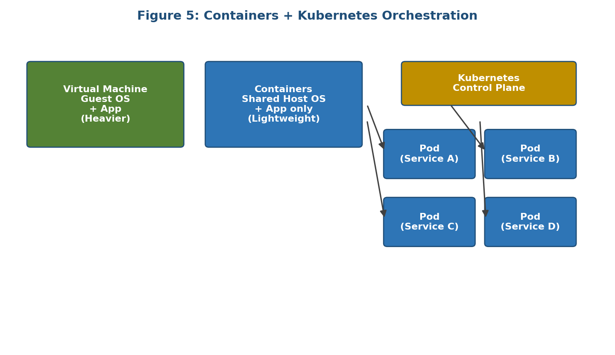
Figure 5: Lightweight containers vs. heavier VMs, orchestrated by Kubernetes across services.

How Orchestration (Kubernetes) Simplifies Deployment and Scaling
- Automated scheduling: Kubernetes decides which physical/virtual node each container (packaged as a 'pod') runs on, based on available resources, without engineers manually placing workloads.
- Self-healing: If a container crashes or a node fails, Kubernetes automatically restarts or reschedules the affected pods elsewhere, reducing manual firefighting.
- Declarative scaling: Engineers declare the desired number of replicas (or an autoscaling rule based on load), and Kubernetes continuously reconciles the actual state to match — scaling a service up or down without manual server provisioning.
- Rolling updates and rollbacks: New versions can be deployed gradually with automatic rollback if health checks fail, reducing deployment risk.

Portability Benefits Across Cloud Environments
Because a container packages the application with all its dependencies into one standard, OS-agnostic image, that same image runs identically on a developer's laptop, an on-premises server, or any major cloud provider's infrastructure. Kubernetes itself is available as a managed service on every major cloud and can also run on-premises, so the same deployment manifests can be applied across environments with minimal change — directly supporting multi-cloud or hybrid strategies and avoiding vendor lock-in.

Microservices-Based Application Example
An online food-delivery platform might be built as a set of independent microservices — order management, restaurant catalog, payment processing, delivery tracking, and notifications — each packaged as its own container and deployed on a shared Kubernetes cluster. Each service can be developed, deployed, scaled, and updated independently (for example, scaling the delivery-tracking service during dinner rush without touching the others), which is exactly the kind of granular, resilient deployment model containers and orchestration are designed to enable.

Application Based Questions Rubric
Criteria | Weightage | Level 4 -  Exemplary | Level 3 -  Proficient | Level 2 -  Developing | Level 1 -  Beginning
Relevance to Application | 25% | Response directly addresses the given use case with strong relevance | Mostly relevant response | Partially relevant | Weak  relevance
Use of Cloud Concepts | 25% | Applies appropriate concepts accurately | Mostly accurate application | Basic application only | Incorrect concept usage
Practical Insight | 20% | Shows strong real-world understanding | Shows reasonable practical understanding | Limited practical insight | No practical insight
Completeness | 15% | Response covers all required aspects | Covers most aspects | Covers only basic aspects | Incomplete response
Clarity | 15% | Clear and concise answer | Generally clear | Some  confusion in expression | Poor clarity

